Heart of the Gospel Retreat
Full One-Day Retreat Saturday August 29th All Men Welcome!

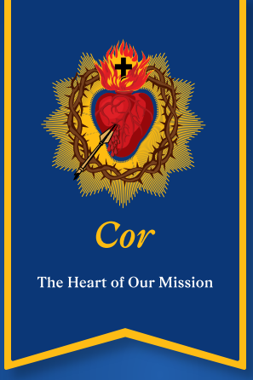
Sponsored by
Our Lady of the Lakes Catholic Church – Waterford, MI
& Knights of Columbus – Council 5436
Preview here: Heart of the Gospel Retreat - Intro Video
Questions: Michael Mandziuk: m.mandziuk@mikofc.org

