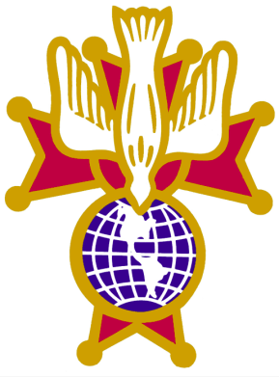
All 3rd Degree Knights are invited to join the Patriotic 4th Degree!
As the Faithful Navigator of the Divine Mercy Assembly #3082, I personally would like to invite all 3rd Degree Knights to join the Patriotic 4th Degree Knights of Columbus.
- We focus our programs on helping our veterans and our country.
  - Fourth Degree Knights are called to exemplify patriotism and the highest ideals of Catholic citizenship, which includes deep spiritual commitment and public witness to faith.
  - The Fourth Degree is the most ceremonial and public-facing degree of the Knights, emphasizing patriotism and faith in action
  - We foster fraternity and unity, especially among Fourth Degree members who often serve together in visible roles during parish and diocesan Advent activities.
  - We support the Military Chaplain’s scholarship program that was established in 2011 to help fund the education of seminarians preparing to become Catholic chaplains in the U.S. Armed Forces.
Please join and help support our Veterans!

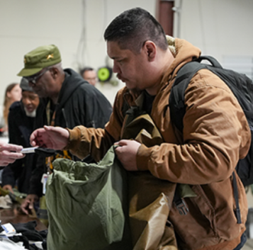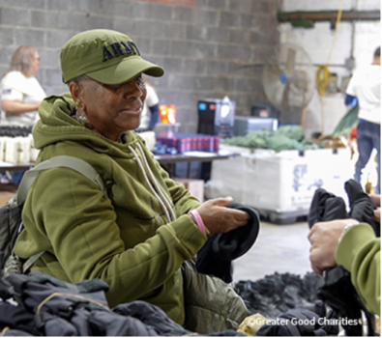

Any 3rd Degree Knight of Columbus member in good standing can join the Patriotic 4th Degree.

4th Degree Exemplifications:
- Saturday, April 25, 2026, at Our Lady of the Lakes Catholic Church, Waterford Township
  - Note: You must be signed up by April 5th for this Exemplification
- Monday, May 11: Wyandotte Knights of Columbus Hall, Wyandotte
- Wednesday, May 27: Our Lady Queen of Peace Knights of Columbus Hall, Imlay City
- Monday, June 1: St. Therese of Lisieux, Shelby Twp
- Monday, June 8: Monroe Knights of Columbus Hall, Monroe

Good News for all Knights that join the 4th Degree in 2026, and join the Color Corps.

4th Degree Color Corps (voluntary and very rewarding)
In September of 2025 the 4th Degree Divine Mercy Assembly #3082 increased the financial help to all 4th Degree members that join the Color Corp from $200 to $300. This is to help with the cost of their Color Corps Uniform. This $300 is for all 4th Degree Knights in our Divine Mercy Assembly #3082.
In December 2025, our Assembly received a generous $1,000 anonymous donation from one of our Assembly members that is designated for Color Corps uniforms.
The requirements for the distribution of this $1,000 donation are as follows:
- The next 10 Knights that join the 4th Degree Divine Mercy Assembly #3082 after January 1, 2026, and join the Color Corps will receive an additional $100 to go along with the existing $300 toward their Color Corps Uniform. This is a great opportunity for our Color Corps to grow.
- The $400 will be given to the new Color Corps member after they complete 6 fallout assignments. This goal can quickly be achieved.
  - A few examples of fallout assignments are:
o Corporate Communions o Sacrament of Confirmation
o Casket Watches o Funerals
o Memorial Masses o March in Parades
o Right to Life Masses o Live Rosarys
o Council Anniversary Masses o Others

Please consider joining the Knights of Columbus Patriotic 4th Degree
Thank you for all you do!
God bless each of you and your families,

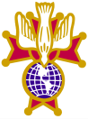 Gary Parent
Faithful Navigator
Divine Mercy Assembly #3082
garyparent22@gmail.com

